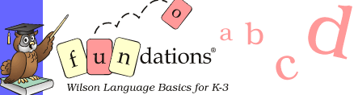

All learning involves active participation
Fundations instruction is visible and explicit. Unlike many programs where students work independently on phonics worksheets, all Fundations instruction is interactive. The multisensory Lesson Activities provide learning through various modalities and help to maintain the students’ focus. Students find learning fun.
Lesson Activities include:
Letter formation using sky writing, dry erase boards, notebooks, and finger tracing (cursive letter formation in Level 3)
Fluency drills for sounds, real words, nonsense words, trick words, phrases and stories allow students to connect the word with its meaning, and develop automaticity, phrasing, and expression (includes recording charts and fluency drills for each unit in Level 1 and 2)
Guess Which One in Level 3 helps students develop vocabulary and spelling skills with homophones by distinguishing differences in meaning in the context of various sentences
Alphabet sequencing with sound cards or Magnetic Building Board with alphabetic overlay and phoneme tiles
Blending and segmenting sounds with the Wilson finger tapping technique
Sound drill with Echo the Owl and Large or Standard Sound Cards
Echo/Find Letters and Words using the Magnetic Letter Board and phoneme tiles
Dictation for sounds, words, and sentences using the dry erase board and composition books
Trick words (high-frequency non-phonetic words) using sky writing, gel boards, composition books, flashcards, and notebooks
Word of the Day activity reviews word structure and develops vocabulary using sound cards, index cards, and Vocabulary section of the notebook
Word Talk, Word Play and Make it Fun are variable lesson activities using the manipulatives to reinforce unit concepts or review previously taught concepts
Storytime involves reading and writing activities, including using stories with controlled text

